**MODULE 2**

In today’s fast-paced digital era, marketing has evolved far beyond traditional methods. Digital marketing has emerged as a powerful tool that allows businesses to connect with their target audience through digital platforms such as social media, search engines, websites, and email. It encompasses a wide range of strategies, including search engine optimization (SEO), pay-per-click advertising (PPC), content marketing, and more. This assignment explores the core concepts, tools, and strategies involved in digital marketing, highlighting its growing importance in building brand awareness, driving customer engagement, and increasing business growth.

**ANS 1**

### **Where Can We Promote TOPS Technologies Pvt. Ltd.?**

Let’s explore the **Traditional** and **Digital** platforms where TOPS Technologies — a leading IT training and placement company — can effectively promote its services.

### **🔹 Traditional Platforms:**

1. **Newspapers & Magazines** – Ideal for local awareness and student/parent readership.
2. **Radio Ads** – Great for creating brand recall during peak travel hours.
3. **Pamphlets & Flyers** – Useful for campus distribution and walk-ins.
4. **Billboards & Hoardings** – High visibility at coaching hubs and education zones.
5. **Seminars & Workshops** – Offline events in colleges and schools.

### **🔹 Digital Platforms:**

1. **Instagram & Facebook Ads** – Best to target students aged 16–28 with creative, visual content.
2. **Google Ads** – Captures users actively searching for courses like “Python classes near me.”
3. **LinkedIn** – Effective for B2B connections, career guidance, and corporate training tie-ups.
4. **YouTube** – Perfect for video tutorials, testimonials, and success stories.
5. **Email Marketing** – Great for lead nurturing, course updates, and promotions.

### **🎯 Best Platform Recommendation:**

**Digital Platforms** are the clear winner for **TOPS Technologies**, and here’s why:

**Reason:** Most of TOPS Technologies’ audience — students, job seekers, and tech learners — are active online. Digital platforms allow for **targeted, cost-effective, and measurable** marketing. With tools like SEO, social media ads, and remarketing, the company can reach the right learners at the right time — across cities and devices — with a high ROI.

**ANS 2**

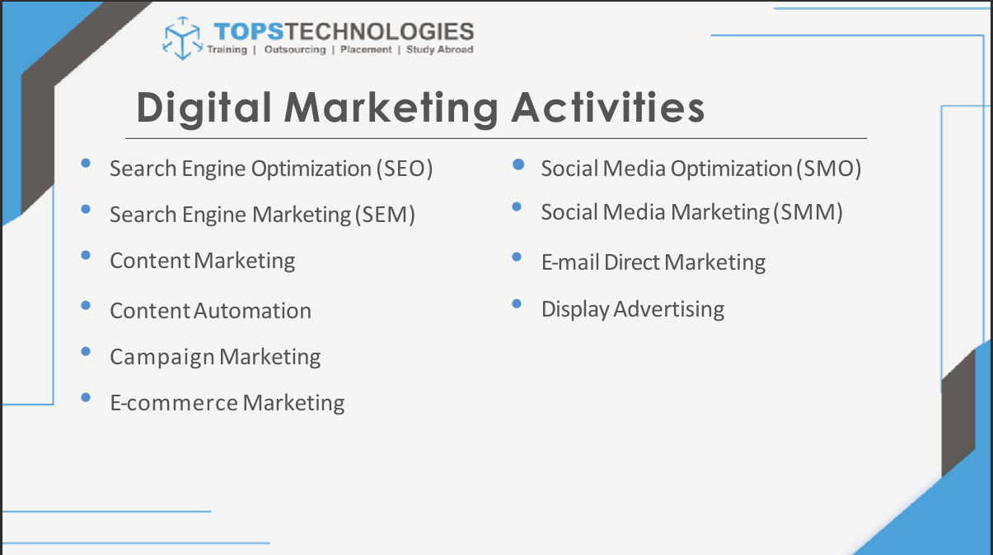

### **Search Engine Optimization (SEO)**

**Uses:**

To improve website visibility in search engines like Google.  
 ✅ Attracts organic traffic and qualified leads.

1. **Search Engine Marketing (SEM)**

**Uses:**

It helps drive instant traffic, increase visibility, and attract potential customers actively searching for related products or services.

### **Content Marketing**

**Uses:** To educate and engage audiences by providing valuable information (blogs, videos, infographics).  
 ✅ Builds trust and positions the brand as an expert.

1. **Content automation**

**Uses:**

It helps streamline the creation, scheduling, and distribution of marketing content using AI and tools. It saves time, ensures consistency, and boosts efficiency across multiple platforms.

1. **Campaign marketing**

**Uses:**

It is used to promote a specific goal, product, or message over a set period using coordinated strategies. It helps increase brand visibility, generate leads, and drive customer engagement through targeted communication.

1. **E-commerce marketing**

**Uses:**

It is used to drive traffic to online stores and convert visitors into paying customers. It helps promote products digitally through SEO, social media, email, and paid ads to boost online sales.

1. **Social Media Optimization (SMO)**

**Uses:**

It increases brand visibility by enhancing content and engagement across social media platforms.It helps drive traffic to your website and builds a loyal online community through consistent, shareable content.

### **Social Media Marketing(SMM)**

**Uses:**

It reaches and interacts with customers directly on platforms like Instagram, Facebook, LinkedIn, and Twitter to boost engagement and brand loyalty.

### **Email Direct Marketing:**

**Uses:**

It sends personalized messages, updates, or offers to customers’ inboxes to maintain relationships and drive conversions.

1. **Display Advertising:**

**Uses**:

It increases brand visibility by showcasing visual ads across websites, apps, and social media.It helps attract targeted audiences, boost traffic, and drive conversions through eye-catching creatives.

**ANS 3**

**Traffic** refers to the number of visitors who land on a website. It shows how many people are engaging with your site and is crucial for online visibility and conversions.

### **Types of Website Traffic:**

#### **1. Organic Traffic:**

* Visitors who come to your website through unpaid search engine results (like Google).
* Achieved through SEO (Search Engine Optimization), quality content, and keyword ranking.

#### **2. Inorganic (Paid) Traffic:**

* Visitors who land on your website through paid advertisements (like Google Ads, social media ads).
* Achieved through PPC (Pay-Per-Click) campaigns or display marketing.

In short:  
 **Organic = free but long-term**,  
 **Inorganic = paid but instant.**

**ANS 4**

Here are **key things to consider while choosing a domain name for a company**:

1. **Keep it Short & Simple** – Easy to remember, type, and spell.
2. **Use Keywords** – Include relevant terms related to your business or services.
3. **Brandable & Unique** – Should reflect your brand identity and stand out.
4. **Choose the Right Extension** – Prefer .com, but use .in, .net, etc., if needed.
5. **Avoid Numbers & Hyphens** – They create confusion and are hard to recall.
6. **Check Availability** – Ensure the domain and social media handles are available.
7. **Easy to Pronounce** – Helps in word-of-mouth marketing and brand recall.
8. **Think Long-Term** – Choose a name that fits future growth or expansion.

**ANS 5**

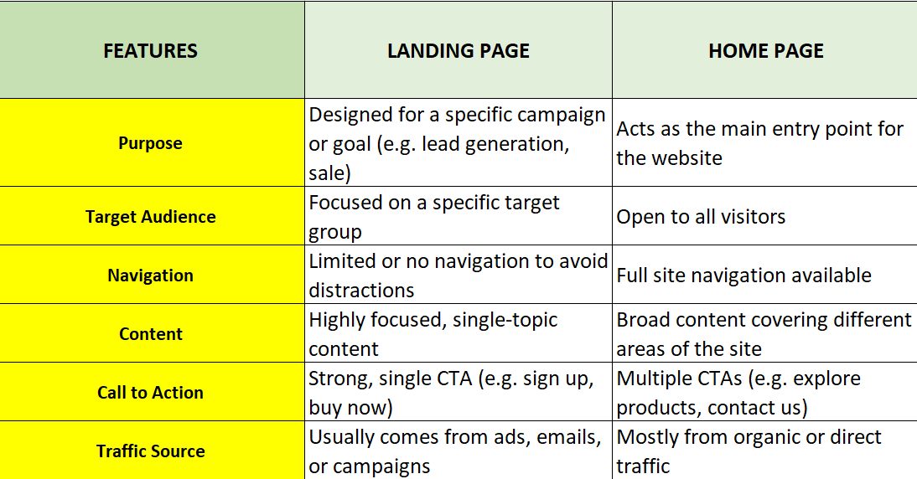

**In short:**

* **Landing Page = Action-driven and conversion-focused**
* **Home Page = Overview of your brand or website**

**ANS 6**

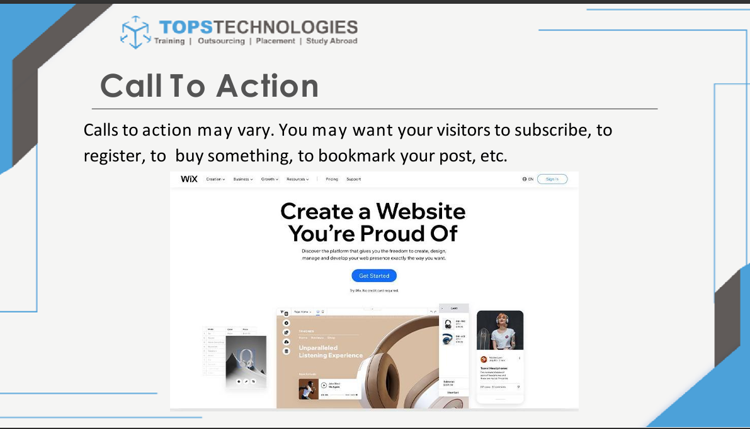

Add to Cart

Buy Now

Shop Now

Checkout

View Product

Apply Coupon

Continue Shopping

Sign Up & Save

Track Your Order

Subscribe for Offers

Limited Time Deal – Grab Now

Get Free Shipping

Add to Wishlist

See More Details

Leave a Review

**ANS 7**

### **Add-ons/Modifiers You Can Use with Keywords:**

1. **Long-tail Keywords**
   * More specific phrases (e.g., *“best DSLR camera under 50000”*).
2. **Location-Based Keywords**
   * Add a place to target local audiences (e.g., *“digital marketing agency in Ahmedabad”*).
3. **Action Words (Transactional)**
   * Words like *buy, book, order, download, hire* to target users with intent.
4. **Product or Brand Names**
   * Include specific brands or models (e.g., *“Nike running shoes”*).
5. **Time-Based Modifiers**
   * Include words like *“2025,” “latest,” “today”* (e.g., *“top smartphones 2025”*).
6. **Question-Based Keywords**
   * Use *what, how, why, where* for blog or FAQ content (e.g., *“how to choose a domain name”*).

**ANS 8**

### **🔍 1. Panda (2011)**

**Purpose:** To lower the rank of low-quality or thin content.  
 **Effect:** Penalized sites with duplicate, plagiarized, or shallow content.  
 ✅ Encouraged high-quality, original content.

### **🔗 2. Penguin (2012)**

**Purpose:** To reduce webspam and manipulative link building.  
 **Effect:** Penalized sites using black-hat SEO techniques like keyword stuffing and buying links.  
 ✅ Rewarded natural link profiles.

### **📱 3. Mobile-Friendly Update (Mobilegeddon) (2015)**

**Purpose:** To improve rankings for mobile-optimized websites.  
 **Effect:** Non-mobile-friendly sites saw ranking drops in mobile searches.  
 ✅ Boosted mobile usability and responsive design.

### **⚡ 4. RankBrain (2015)**

**Purpose:** AI-based update to better understand search intent.  
 **Effect:** Improved search result relevance; focused more on user intent than exact keyword match.  
 ✅ Encouraged content that answers user queries clearly.

### **🏗️ 5. BERT (2019)**

**Purpose:** To understand natural language and context better.  
 **Effect:** Improved how Google interprets queries with prepositions and nuances.  
 ✅ Promoted well-written, context-rich content.

### **🌐 6. Core Web Vitals (2021)**

**Purpose:** To improve user experience based on speed, responsiveness, and visual stability.  
 **Effect:** Affected rankings based on loading performance, interactivity, and layout shift.  
 ✅ Encouraged technical optimization.

### **📅 7. Helpful Content Update (2022)**

**Purpose:** To promote people-first content over SEO-only content.  
 **Effect:** De-ranked sites with content created only to rank, not to help users.  
 ✅ Rewarded genuinely useful and expert-written content.

**ANS 9**

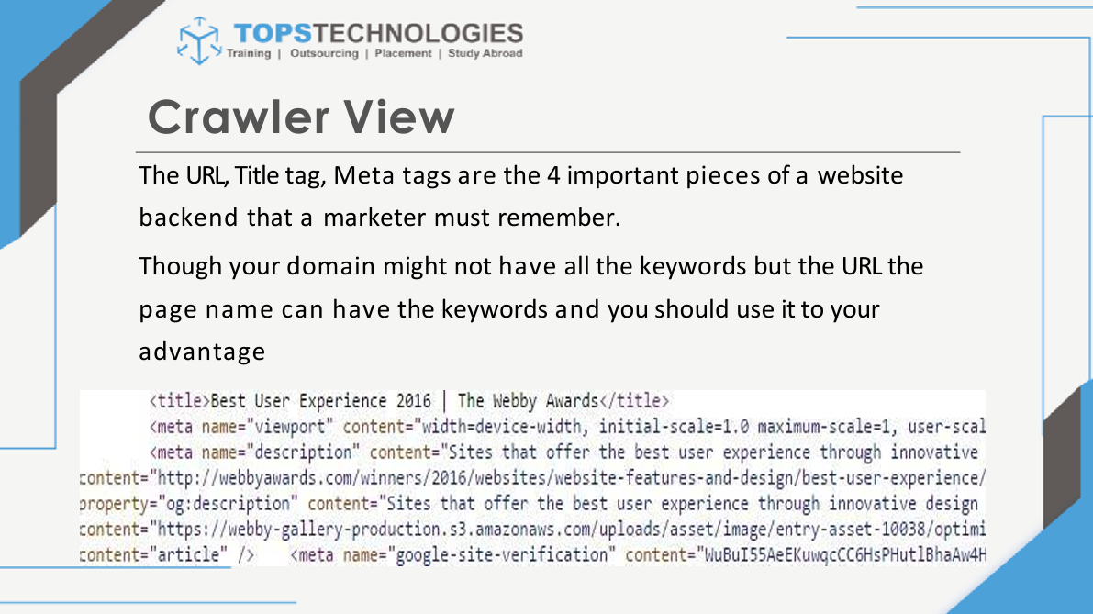

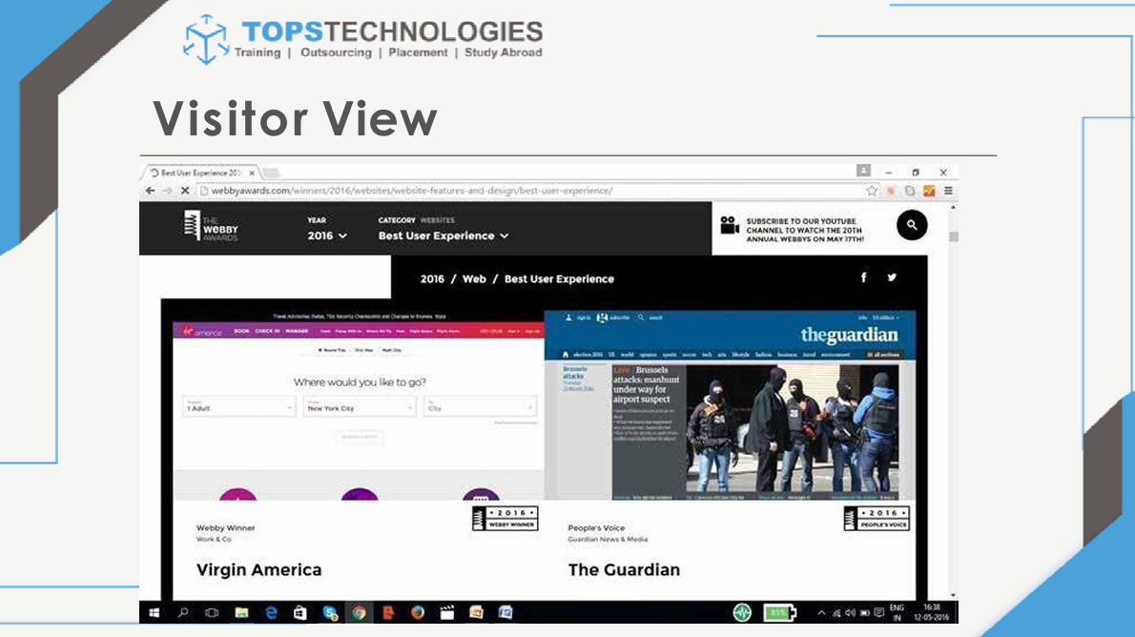

### **🕷️ Crawling and Indexing in SEO**

#### **1. Crawling**

* **What is it?** Crawling is the process where search engine bots (also called "spiders" or "crawlers") systematically browse the internet to discover new or updated pages.
* **Who does it?** It’s performed by **search engine bots** like **Googlebot** (for Google), **Bingbot** (for Bing), etc.
* **Goal:** To find and collect data from webpages by following links from one page to another.

#### **2. Indexing**

* **What is it?** Indexing is the process of storing and organizing the content found during crawling into the search engine’s database (the “index”).
* **Who does it?** After crawling, the **search engine’s indexing system** processes and analyzes the content.
* **Goal:** To understand the page’s content and relevance so it can appear in search results.

### **📝 In Simple Terms:**

* **Crawling = Discovering** web pages.
* **Indexing = Understanding and saving** those pages for search results.

**ANS 10**

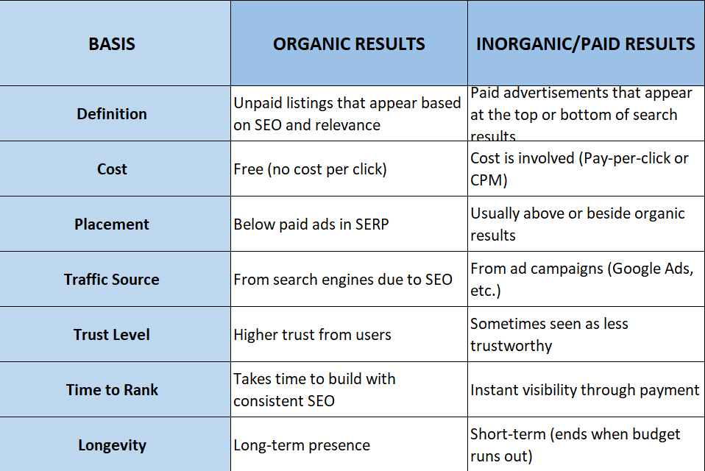

### **Example:**

* **Organic**: A blog post that appears in Google results because it’s optimized for SEO.
* **Inorganic**: A Google ad at the top that says “Sponsored” or “Ad”.

**ANS 11**

<https://dmseotrend2025.blogspot.com/>

**ANS 12**

[**https://meetstores.weebly.com**](https://meetstores.weebly.com/)